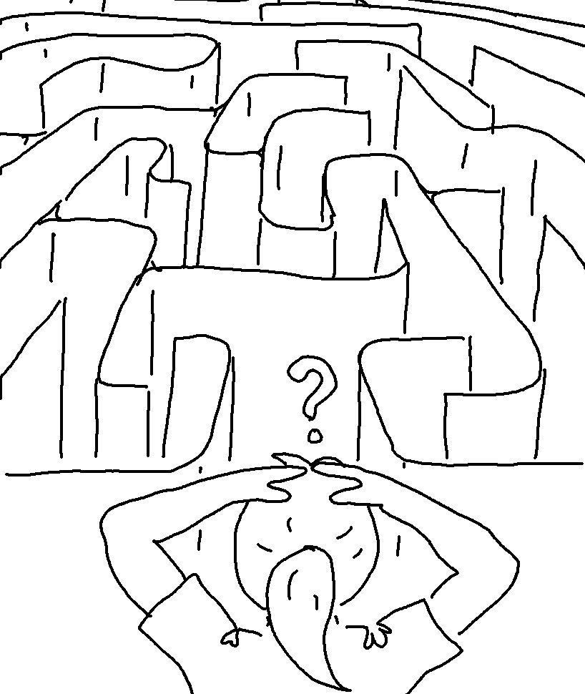
If you love me, obey my commandments. John 14:15_{NLT}

